Apache Spark
Apache spark is an open source distributed data processing framework mainly designed for large data process.
It perform in memory computation, making it mush faster than traditional MapReduce
Hadoop : Hadoop mainly use MapReduce concept for data processing.
Apache Spark support all maximum language like, Java, Scala, Python, C#, Node JS etc.
PySpark : PySpark is the python API for Apache Spark
It allow python developer and data engineers to use the Spark features using python language.
When we need to use PySpark
- Data is > System memory.
- Data stored HDFS (Hadoop Distributed File system), S3 or any cloud provided. etc.
- Batch processing + streaming
- ML modules
- Real time analytics

PySpark provided lot of modules which help to do distributed computing
- PySpark Core (RDD)
- PySpark SQL
- PySpark Streaming
- PySpark MLib
- PySpark GraphX

NumPy
Pandas
Dask
PySpark

Features | NumPy | Pandas | Dask | PySpark
Data size | Small | Medium | Large | Very Large
Execution | Single machine | Single Machine | Parallel | Distributed
Memory | In memory | In memory | Out of Core | In memory + disk
Fault tolerance | Not apply | No apply | Limited | Yes
Streaming | No | No | Limited | Yes
SQL | No | No | No | Yes
ML | Limited | Limited | Limited | Strong
Cluster | No | No | Partially | Full

Open the folder and write the below command to create python virtual environment folder
Please install python 3.10 with blow link
https://www.python.org/ftp/python/3.10.11/python-3.10.11-amd64.exe

py -0

using python 3.10 with environment variable.

py -3.10 -m venv spark-evn
activate virtual environment folder

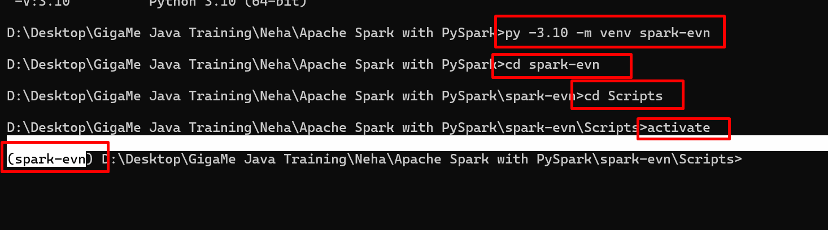

Now we will install pyspark module

python -m pip install pyspark==3.5.1
Python Core provided one the module
Pyspark RDD : Resilient Distributed Dataset
Resilient - automatically recover from failure while dealing with huge data.
Distributed data is split across multiple machine or nodes.
DataSet - Like Set, List, or file or database of mysql or mongo db

